Objectives Achieved
- Learned to use State Machine as a program design tool
- Practiced conditional execution of code combined with loops by implementing State Machines
- Understood different data types in C (int, char, float, double)
Task 1: Mathematical Expression Calculator
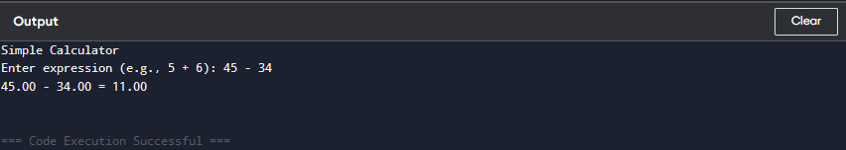
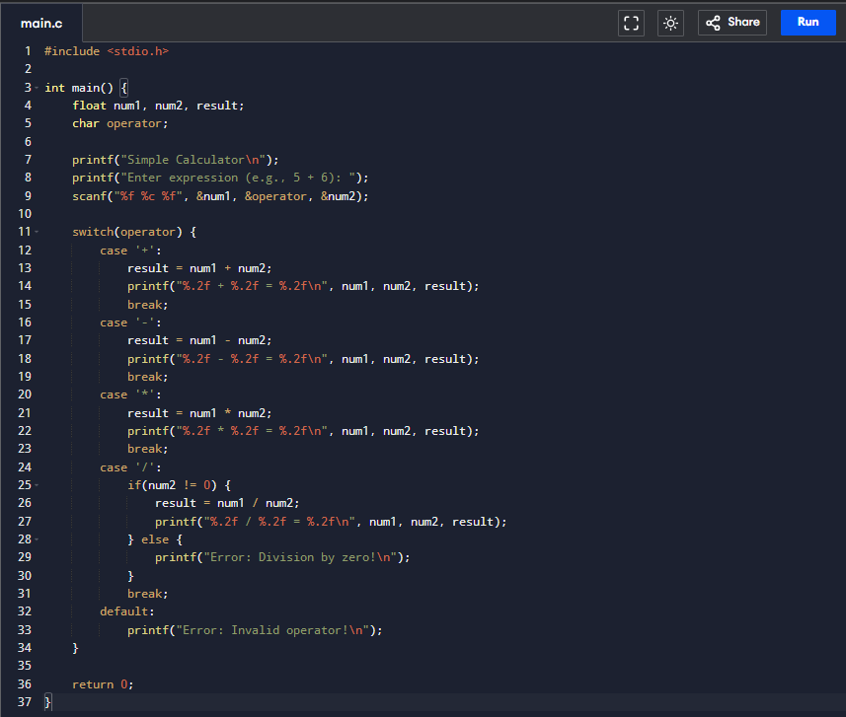
- Program code
Conclusion of Task 1
In Task 1, we explored different data types in C such as int, char, and float. This helped us understand how data is stored and represented in memory. We also learned that each data type has a specific size and purpose. The task improved our basic understanding of variable declaration and usage.

Task 2: Menu Driven Program (Switch + Loop)
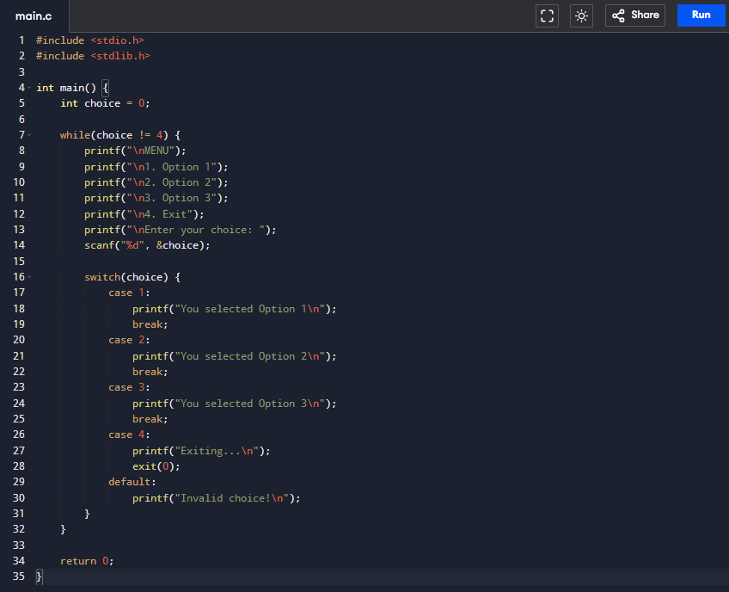
- Program code
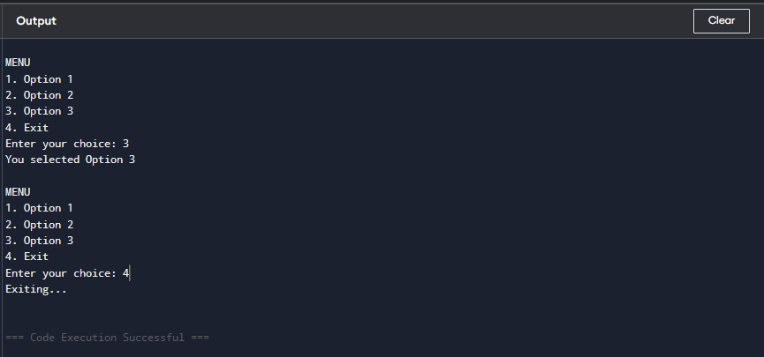

Conclusion of Task 2
This task focused on the use of the switch statement and character handling. We learned how characters are internally stored using ASCII values. This task helped us understand decision-making in programs and how multiple conditions can be handled efficiently using switch instead of multiple if-else statement.

Task 3: State Machine (a, b, e transitions)
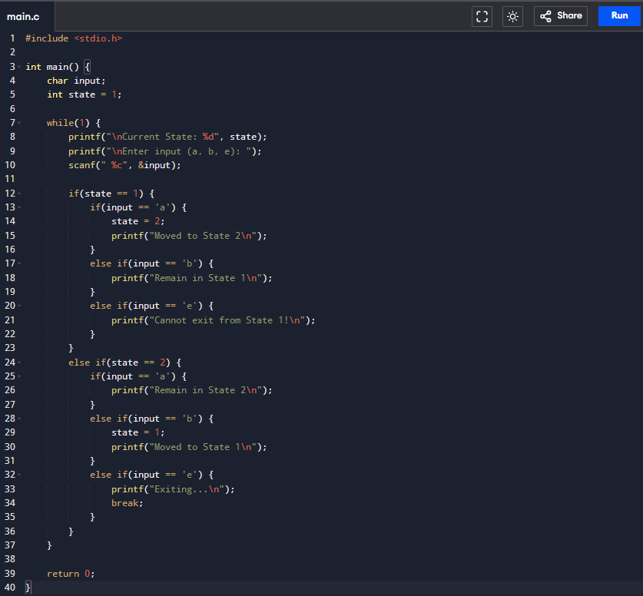
- Program code
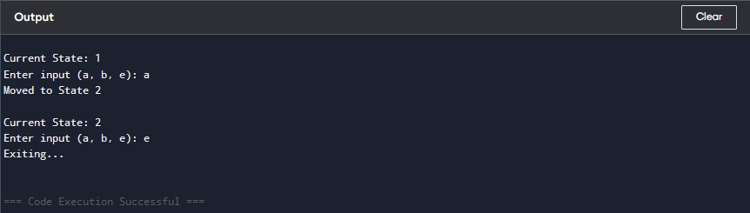

Conclusion of Task 3
In Task 3, we implemented a simple finite state machine using conditional statements. This helped us understand how a system changes states based on input. We learned how logic flows step-by-step in programs and how states are interconnected. This task strengthened our logical thinking and debugging skills.

Post-Lab Task: State Machine (Custom FSM)
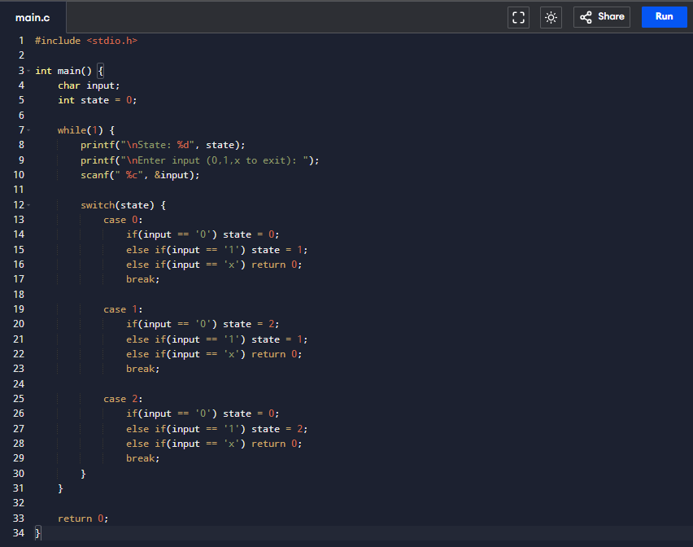
- Program code
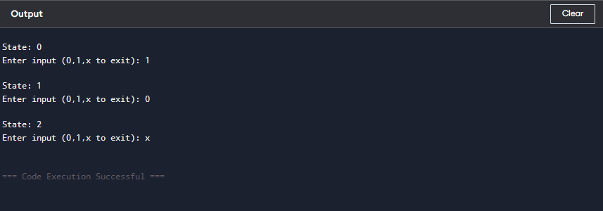

Conclusion of Post-Lab Task
The post-lab task enhanced our understanding of state machines by applying them to a more complex problem. We faced challenges in managing multiple conditions and transitions between states. However, this task improved our problem-solving skills and helped us understand real-world applications of programming concepts.
Critical Analysis
This lab provided valuable hands-on experience with data types and finite state machines in C programming. The progression from a simple calculator (Task 1) to a menu-driven program (Task 2) and finally to state machines (Task 3 and Post-Lab) effectively built upon concepts incrementally.
Key observations:
- Different data types (int, char, float) serve specific purposes and must be chosen carefully based on the requirements
- Switch statements offer cleaner alternatives to multiple if-else statements when handling multiple cases
- State machines provide an intuitive way to model systems that behave differently based on their current state
- The transition from a 2-state to a 4-state machine demonstrates the scalability of FSM-based program design
Challenges faced:
- Handling character input with scanf required attention to whitespace consumption
- Ensuring proper break statements in nested switches to prevent fall-through
- Implementing circular state transitions required careful mathematical logic

